# 1.INTRODUCTION

## 1.1 Project Title: FitFlex

**1.2 Team ID :SWTID1741256457158870**

**1.2 Team member :**

1. **THABASUM S F (farufarhana85@gmail.com)**
2. **AKILA S(akiladeviakiladevi27@gmail.com)**
3. **MADHUMITHA R(madhumitha18052005@gmail.com)**
4. **DIVYA E(divyaelumalai0914@gmail.com)**

**2. PROJECT OVERVIEW**

* 1. **Purpose:**

**The purpose of this fitness app is to empower users to take control of their health and fitness journey by providing personalized workout plans, progress tracking, and access to expert guidance. It aims to create a seamless and engaging experience that encourages consistency, motivation, and long-term fitness habits.**

**By integrating interactive features, such as goal setting, activity tracking, and performance analytics, the app helps users stay accountable and make informed decisions about their fitness routines. Additionally, it strives to foster a supportive community where users can share their achievements, challenges, and insights, making fitness more accessible and enjoyable for everyone.**

* 1. **Features:**

The fitness app offers a comprehensive suite of features designed to enhance the user’s fitness journey. It includes secure authentication with login, registration, and profile management. Users can access a variety of workout programs, including predefined plans and customizable routines tailored to individual fitness goals. Video demonstrations provide clear guidance on exercises, ensuring proper form and technique. Progress tracking allows users to monitor their achievements with detailed insights, workout history, and goal-setting tools.

The app may also support nutrition tracking with meal plans, calorie counting, and personalized diet recommendations. Community features enable users to connect, share progress, participate in challenges, and engage in discussions through forums or chat. Motivational notifications and workout reminders help maintain consistency and encourage users to stay on track. Integration with wearable devices like Fitbit, Apple Health, or Google Fit allows seamless syncing of activity data. Multi-device support ensures accessibility across smartphones, tablets, and other compatible platforms, making fitness management more convenient and efficient.

# 3.ARCHITECTURE

**3.1 Component Structure:**

Here’s a more detailed component structure of your React-based fitness app with subheadings and expanded explanations.

**1. Root Structure:**

**The project follows a modular and scalable architecture.**

**/fitnessapp**

**│── /public**

**│── /src**

**│ ├── /assets**

**│ ├── /components**

**│ ├── /pages**

**│ ├── /context**

**│ ├── /hooks**

**│ ├── /utils**

**│ ├── /services**

**│ ├── /config**

**│ ├── /routes**

**│ ├── App.js**

**│ ├── index.js**

**│── package.json**

**│── README.md**

1. **Assets (/assets):**

This folder contains static files such as images, icons, and styles.

**/images – Stores images used in the app**

**/icons – SVG and icon files /styles – Global stylesheets or SCSS files**

1. **Components (/components):**

Reusable UI elements that enhance the app’s modularity.

Layout Components

These manage the general structure of the app.

**Header.js – Navigation bar with links**

**Footer.js – Footer section with additional links**

**Sidebar.js – Sidebar navigation for the dashboard**

**UI Elements**

Reusable elements that can be used across multiple screens.

**Button.js – Custom button component**

**Card.js – General card component for displaying content**

**Loader.js – Loading spinner animation**

**Modal.js – Pop-up modal for alerts and dialogs**

**Feature-Specific Components:**

These components handle specific features of the fitness app.

**WorkoutCard.js –** Displays individual workout details

**ProgressTracker.js –** Tracks user fitness progress

**Notification.js –** Displays success, warning, or error messages

**ExerciseList.js –** Renders a list of exercises

**ProfileInfo.js –** Shows user profile details

**4. Pages (/pages):**

Each page is a separate view rendered based on the route.

**Authentication Pages**

**Login.js –** Login page for user authentication

**Signup.js –** Registration page for new users

**ForgotPassword.js –** Password recovery screen

**Main App Pages**

**Home.js –** Landing page with an overview of features **Dashboard.js –** User dashboard showing workouts and progress

**Workouts.js –** Displays available workouts

**WorkoutDetail.js** – Shows detailed workout plans

**Progress.js –** User’s fitness progress and achievements

**Profile.js –** User profile settings and account management

**5. Context API (/context)**

**Manages global state and provides shared data to components.**

**AuthContext.js –** Manages user authentication state

**WorkoutContext.js –** Stores and manages workout-related data

**NotificationContext.js –** Handles app-wide notifications

**3.2 State Management:**

Effective state management ensures smooth data flow, improves performance, and enhances scalability. The app likely uses Context API or a state management library like Redux to manage global and local states efficiently.

**1. Global State Management:**

Global state stores data that needs to be accessed across multiple components, ensuring consistency across the application.

**Authentication State:**

Manages user login, signup, and session persistence. It stores authentication status, user details, and access tokens to maintain logged-in sessions and protect restricted routes.

**Workout State:**

Handles user workouts, progress tracking, and exercise details. It fetches data from the backend, updates the UI with real-time workout completion, and allows users to add or modify routines.

**Notification State:**

Manages success, error, and informational messages throughout the app. It ensures real-time updates and automatically clears notifications after a set duration.

**2. Local State Management:**

Local state manages temporary UI interactions within individual components, enhancing user experience without affecting global data.

**Form Handling:**

Tracks input values in forms like login, signup, and profile settings. It validates user inputs, displays error messages, and manages submission states.

**Modal & UI State:**

Controls pop-ups, loading indicators, and toggles, ensuring dynamic UI interactions such as opening and closing modals or managing navigation menus.

**Workout Progress State:**

Updates real-time fitness progress, such as completed workouts and calories burned, ensuring instant feedback for users without requiring global state changes.

**3. State Management Methods**

**Using Context API for Global State:**

A centralized provider ensures all components can access shared data without unnecessary prop drilling.

**Using Custom Hooks for State Management:**

Encapsulates common logic for authentication, API requests, and UI updates, improving code reusability and separation of concerns.

**Using Local State for UI Components:**

Manages interactive elements like modal visibility, form inputs, and loading states to optimize performance and responsiveness.

**4. State Optimization Techniques**

Memoization prevents unnecessary re-renders by caching computed values.

Deferred State Updates improve UI responsiveness by delaying non-urgent updates.

Lazy Initialization optimizes performance by initializing state only when needed.

**3.3 Routing:**

Routing in the fitness app is managed using React Router, allowing seamless navigation between different sections of the application. It ensures users can move between pages like home, login, dashboard, workouts, and progress tracking without reloading the page.

1. **Setting Up Routing:**

The app uses React Router to define routes for each page. The main routes include:

Public Routes: Home, Login, Signup, and NotFound (404).

Protected Routes: Dashboard, Workouts, Workout Details, Progress, and Profile (accessible only after login).

1. **Protected Routes:**

Certain pages require authentication, ensuring that only logged-in users can access them. A PrivateRoute component checks user authentication and redirects unauthenticated users to the login page.

1. **Dynamic Routing:**

The app uses dynamic routes to handle workout details. For example, /workouts/:id fetches a specific workout based on the id parameter.

1. **Navigation with Links:**

Instead of traditional <a> tags, React Router’s Link and NavLink are used to navigate between pages efficiently, preventing full-page reloads

1. **Redirecting Users:**

After login or certain actions, users are automatically redirected using useNavigate(). For example, after a successful login, the user is redirected to the dashboard.

1. **404 Handling;**

If users enter an incorrect URL, they are redirected to a custom 404 page, ensuring a better user experience.

1. **Performance Optimization with Code Splitting:**

To enhance performance, route-based lazy loading is used to load pages only when needed, reducing initial load time.

---

# 4.SETUP INSTRUCTIONS

**4.1 Prerequisites:**

Before setting up and running the React Fitness App, ensure that your system meets the following requirements:

1. **Install Node.js and npm:**

The app is built using React.js, which requires Node.js and npm (Node Package Manager) to run.

**Download Node.js (LTS version):** Node.js Official Website npm comes bundled with Node.js, so installing Node.js will also install npm.

**Verify installation:**

After installation, check if Node.js and npm are installed by running:

**node -v npm -v**

You should see version numbers displayed for both.

1. **Install Git (Optional, if cloning the repository):**

**If you need to clone the project from a repository, install Git:**

**Download Git:** Git Official Website **Verify installation:**

git --version

If installed, this will return the Git version.

1. **Install a Package Manager (npm or yarn):**

The project uses npm by default, but you can also use yarn.

**To install yarn (optional), run:**

**npm install -g yarn**

**Check the version with:**

**yarn -v**

1. **Install a Code Editor (Recommended: VS Code):**

A good text editor improves the development experience.

**Download VS Code:** VS Code Official Website

Install recommended React and ESLint extensions for better coding support.

**5. Install a Web Browser (Recommended: Google Chrome):**

A modern browser is needed for testing the app. Google Chrome is recommended, as it offers great developer tools.

**Download Chrome: Google Chrome Official Website**

**6. Install Node.js Dependencies:**

Once inside the project folder, install all necessary dependencies by running:

**npm install or yarn install**

**4.2 Installation:**

1. **Clone or Download the Project:**

If the project is hosted on a Git repository, use the following command to clone it: git clone https://github.com/your-repo/fitness-app.git cd fitness-app

If you have received the project as a ZIP file, extract it and navigate to the project folder.

1. **Install Dependencies:**

Once inside the project folder, install all required packages by running:

npm install **or, if using yarn:**

yarn install

This will download and set up all dependencies listed in package.json.

1. **Set Up Environment Variables (If Required):**

If the project includes a .env.example file, create a .env file by running:

**cp .env.example .env**

Then, open .env and configure necessary values, such as API keys or database URLs.

**---**

1. **Start the Development Server**

**Run the following command to launch the app:**

npm start or yarn start

This will start a local development server, and the app will be accessible in your browser at:

**http://localhost:**3000

# FOLDER STRUCTURE

**5.1 Client:**

The client-side of the Fitness App follows a structured approach to keep the codebase organized, maintainable, and scalable. Below is the typical React project structure used for the frontend.

/client

│── /public

│ ├── index.html

│ ├── manifest.json

│ ├── favicon.ico

│ └── assets/ (images, icons, etc.)

│

│── /src

│ ├── /components

│ │ ├── Navbar.js

│ │ ├── Footer.js

│ │ ├── Button.js

│ │ ├── Card.js │ │ └── ...

│ │

│ ├── /pages

│ │ ├── Home.js

│ │ ├── Login.js

│ │ ├── Signup.js

│ │ ├── Dashboard.js

│ │ ├── Workouts.js

│ │ ├── Profile.js

│ │ ├── NotFound.js │ │ └── ...

│ │

│ ├── /context

│ │ ├── AuthContext.js │ │ ├── WorkoutContext.js │ │ └── ...

│ │

│ ├── /hooks

│ │ ├── useAuth.js │ │ ├── useFetch.js │ │ └── ...

│ │

│ ├── /services

│ │ ├── api.js

│ │ ├── authService.js │ │ ├── workoutService.js │ │ └── ...

│ │

│ ├── /routes

│ │ ├── AppRoutes.js │ │ ├── PrivateRoute.js │ │ └── ...

│ │

│ ├── /styles

│ │ ├── global.css

│ │ ├── variables.css │ │ ├── components.css │ │ └── ...

│ │

│ ├── App.js

│ ├── index.js

│ ├── reportWebVitals.js

│ ├── setupTests.js │ └── ...

│

│── .env

│── .gitignore

│── package.json

│── README.md

│── yarn.lock / package-lock.json └── ... **Folder Breakdown**

1. **/public:**

Contains static files like index.html, favicon.ico, and assets like images and icons.

index.html serves as the root HTML file for the React app.

1. **/src (Main application source code):**
2. **/components:**

Reusable UI components like Navbar, Footer, Button, and Card.

Keeps UI elements modular and reusable.

1. **/pages:**

Contains page-level components such as Home, Login, Signup, Dashboard, Workouts,

Profile, etc.

These pages are routed via React Router.

1. **/context:**

Stores React Context API files for managing global state.

Example: AuthContext.js manages user authentication state.

1. **/hooks:**

Custom React hooks like useAuth.js and useFetch.js to manage shared logic.

Example: useFetch.js for API requests.

1. **/services:**

Contains API service files for interacting with the backend.

Example: authService.js handles login, signup, and authentication API calls.

1. **/routes:**

Manages React Router routes.

AppRoutes.js defines public and private routes.

PrivateRoute.js ensures only authenticated users can access certain pages. **g) /styles:**

Contains CSS files for styling components and pages.

Example: global.css for global styles, variables.css for theme variables.

1. **App.js:**

The main component that renders the entire app. Wraps everything inside BrowserRouter for routing.

1. **index.js:**

The entry point of the React app.

Renders <App /> inside ReactDOM.createRoot().

# 6.RUNNING THE APPLICATION

Follow these steps to start the Fitness App on your local machine.

**1. Navigate to the Project Directory;**

If you haven’t already, open a terminal and go to the project folder: cd path/to/fitness-app

If the project has separate client and server folders, navigate to the client directory:

cd client

1. **Install Dependencies:**

Ensure all required packages are installed before running the app: npm install or yarn install

1. **Start the Development Server:**

Run the following command to launch the React application: npm start or yarn start

This will start a development server, and the app will open automatically in your default web browser at: [http://localhost:3000](http://localhost:3000/)

1. **Running with Backend (If Applicable):**

If the project has a backend, make sure to start the backend server before running the frontend.

Navigate to the backend directory and start the server:

cd server npm start

Then, in a separate terminal, start the frontend as described in step 3.

**5. Troubleshooting Issues:**

If you encounter errors, try the following:

Port Already in Use (if something else is running on port 3000):

npx kill-port 3000

Then restart the app.

**Dependency Issues:**

Clear the cache and reinstall dependencies: rm -rf node_modules package-lock.json && npm install **Backend Not Connecting:**

Ensure that the API URL in .env is correctly set, e.g.:

REACT_APP_API_URL=http://localhost:5000 Restart the frontend after making changes.

**6. Running in Production Mode (Optional):**

For optimized performance, you can build the app and serve it: npm run build

Then, serve the build using a static server:

npx serve -s build

## 7.COMPONENT DOCUMENTATION

**7.1 Key Components:**

The Fitness App is built using React, following a component-based structure to ensure modularity and reusability. Below are the key components categorized based on their functionality

1. **Layout Components (Shared across multiple pages):**

These components help structure the app and provide navigation.

**Navbar.js** – Contains links to different sections (Home, Workouts, Profile, etc.).

**Footer.js** – Displays copyright and useful links.

**Sidebar.js** – (If applicable) Provides a collapsible menu for easy navigation.

1. **Authentication Components (Handles user authentication & session management):**

These components manage login, signup, and user sessions.

**LoginForm.js** – Provides a login form for user authentication.

**SignupForm.js** – Handles new user registration.

**PrivateRoute.js** – Restricts access to authenticated users only.

1. **Dashboard Components (User-specific information and progress tracking):**

These components display personalized user data.

**Dashboard.js** – Displays an overview of user activity, workouts, and stats.

**Profile.js** – Shows user details, preferences, and settings.

**ActivityChart.js** – (If applicable) Graphically represents workout progress.

1. **Workout & Exercise Components (Core functionality of the app):**

These components handle workouts, tracking, and recommendations.

**WorkoutList.js** – Displays available workouts.

**WorkoutDetail.js** – Shows detailed information about a selected workout.

**ExerciseCard.js** – Represents a single exercise with details like reps, sets, and instructions.

**Timer.js** – A built-in workout timer for tracking exercise duration.

1. **Forms & Input Components (Used for user interaction);**These components handle user input for various actions.

**SearchBar.js** – Allows users to search for workouts or exercises.

**GoalTracker.js** – Lets users set and monitor fitness goals.

**FeedbackForm.js** – Allows users to submit feedback or rate workouts.

1. **API & Data Handling Components (Handles fetching and storing data):**

These components interact with backend services and APIs. **api.js** – Centralized file for API requests. **useFetch.js** – Custom hook for fetching data.

**AuthContext.js** – Manages user authentication state globally.

1. **Utility Components (Reusable small components to enhance UI/UX):**

These components help in UI consistency and user experience.

**Button.js** – A reusable button component.

**Card.js** – Used for displaying workout details, exercises, or user stats.

**Loader.js** – Displays a loading animation while fetching data.

# 8.STATE MANAGEMENT

**8.1 Global States:**

The Fitness App uses the React Context API for managing global state efficiently. This ensures that data like user authentication, workout progress, and user preferences is accessible across different components without the need for prop drilling.

**Authentication State:**

The authentication state stores user login information, including login status and profile details. When a user logs in, their session remains active across different pages. The state also provides functions for logging in and out, updating the stored user data accordingly.

**Workout State:**

The workout state maintains a global list of workouts and exercises. This allows components like the workout list, exercise tracker, and user dashboard to access and modify workout progress seamlessly. Any updates to workouts are reflected throughout the application in real-time.

**State Integration in the App:**

To make the global state accessible, all context providers are wrapped around the main application component. This ensures that any component requiring authentication details or workout data can retrieve them directly from the context without unnecessary prop passing**.**

**Benefits of Global State Management:**

**Efficient Data Sharing –** Ensures that user and workout information is available across multiple components.

**Improved Scalability –** The app can grow without increasing complexity in state management.

**Better Maintainability –** Centralized state management reduces redundancy and improves code readability.

# 9.USER INTERFACE

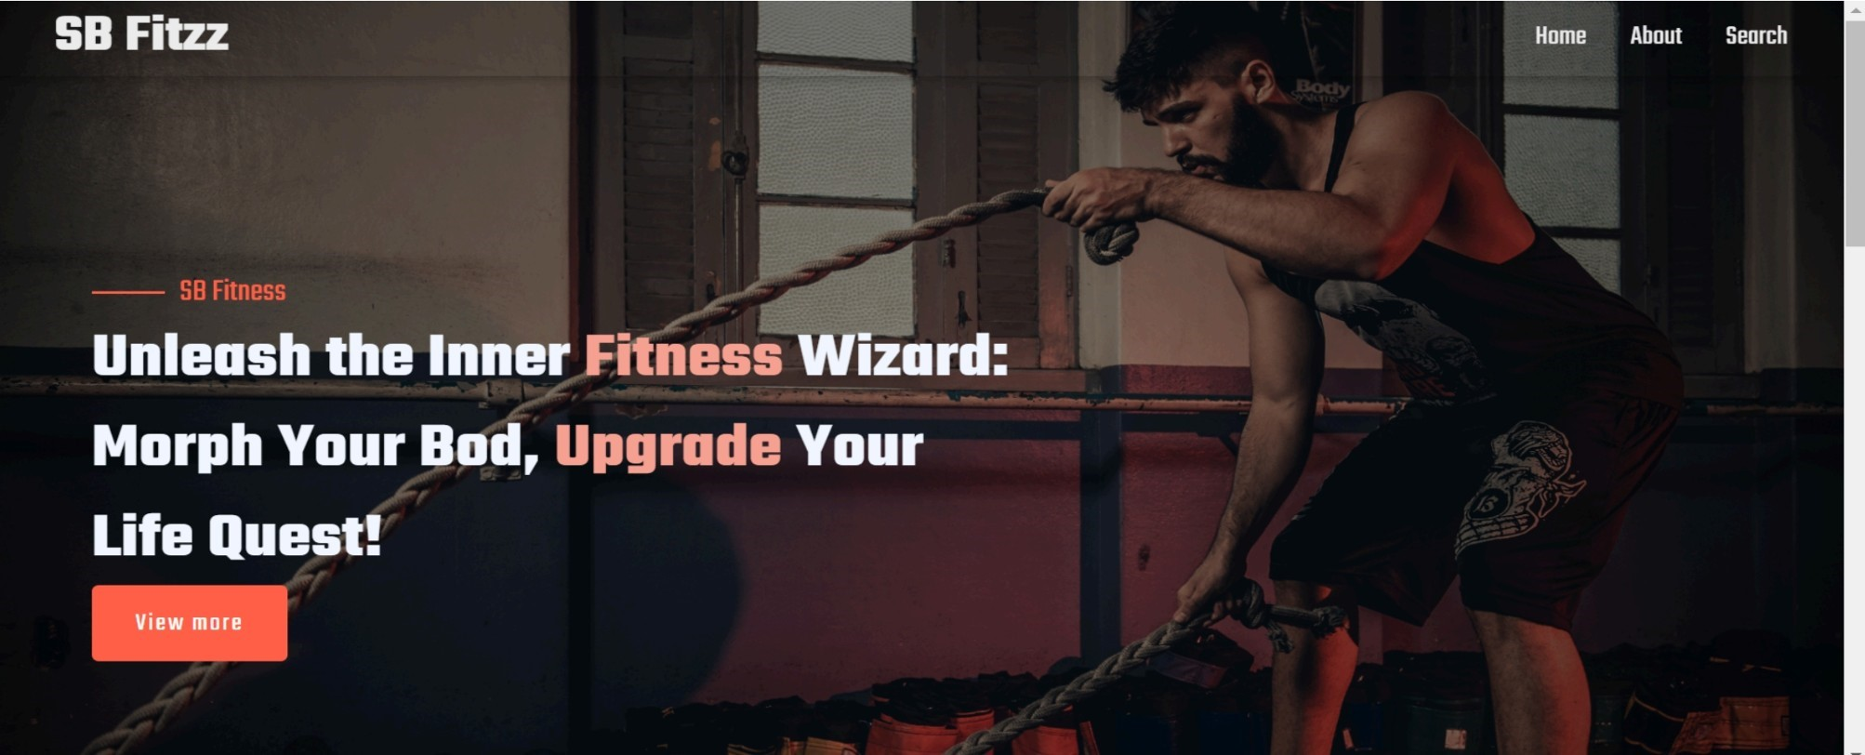

*F014ig 9.1:Screenshot 1*

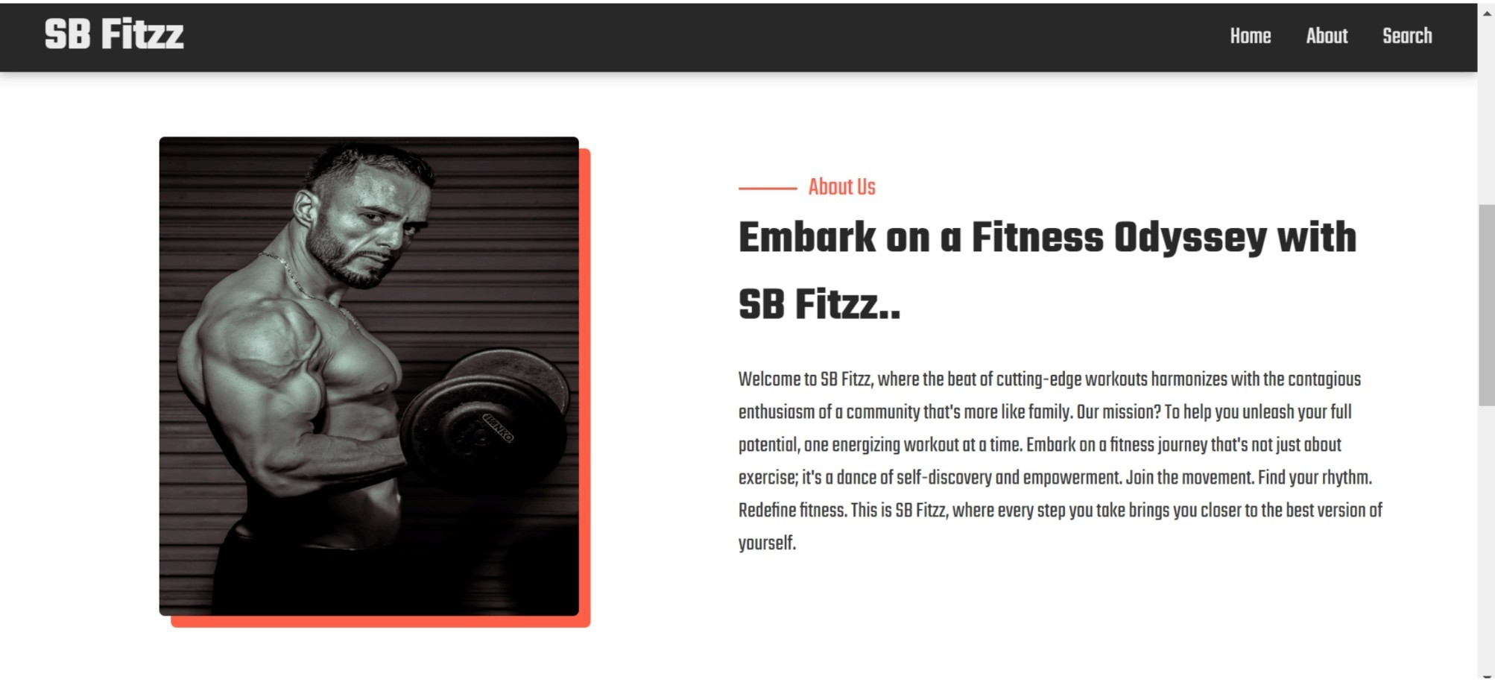

*Fig 9.2:Screenshot 2*

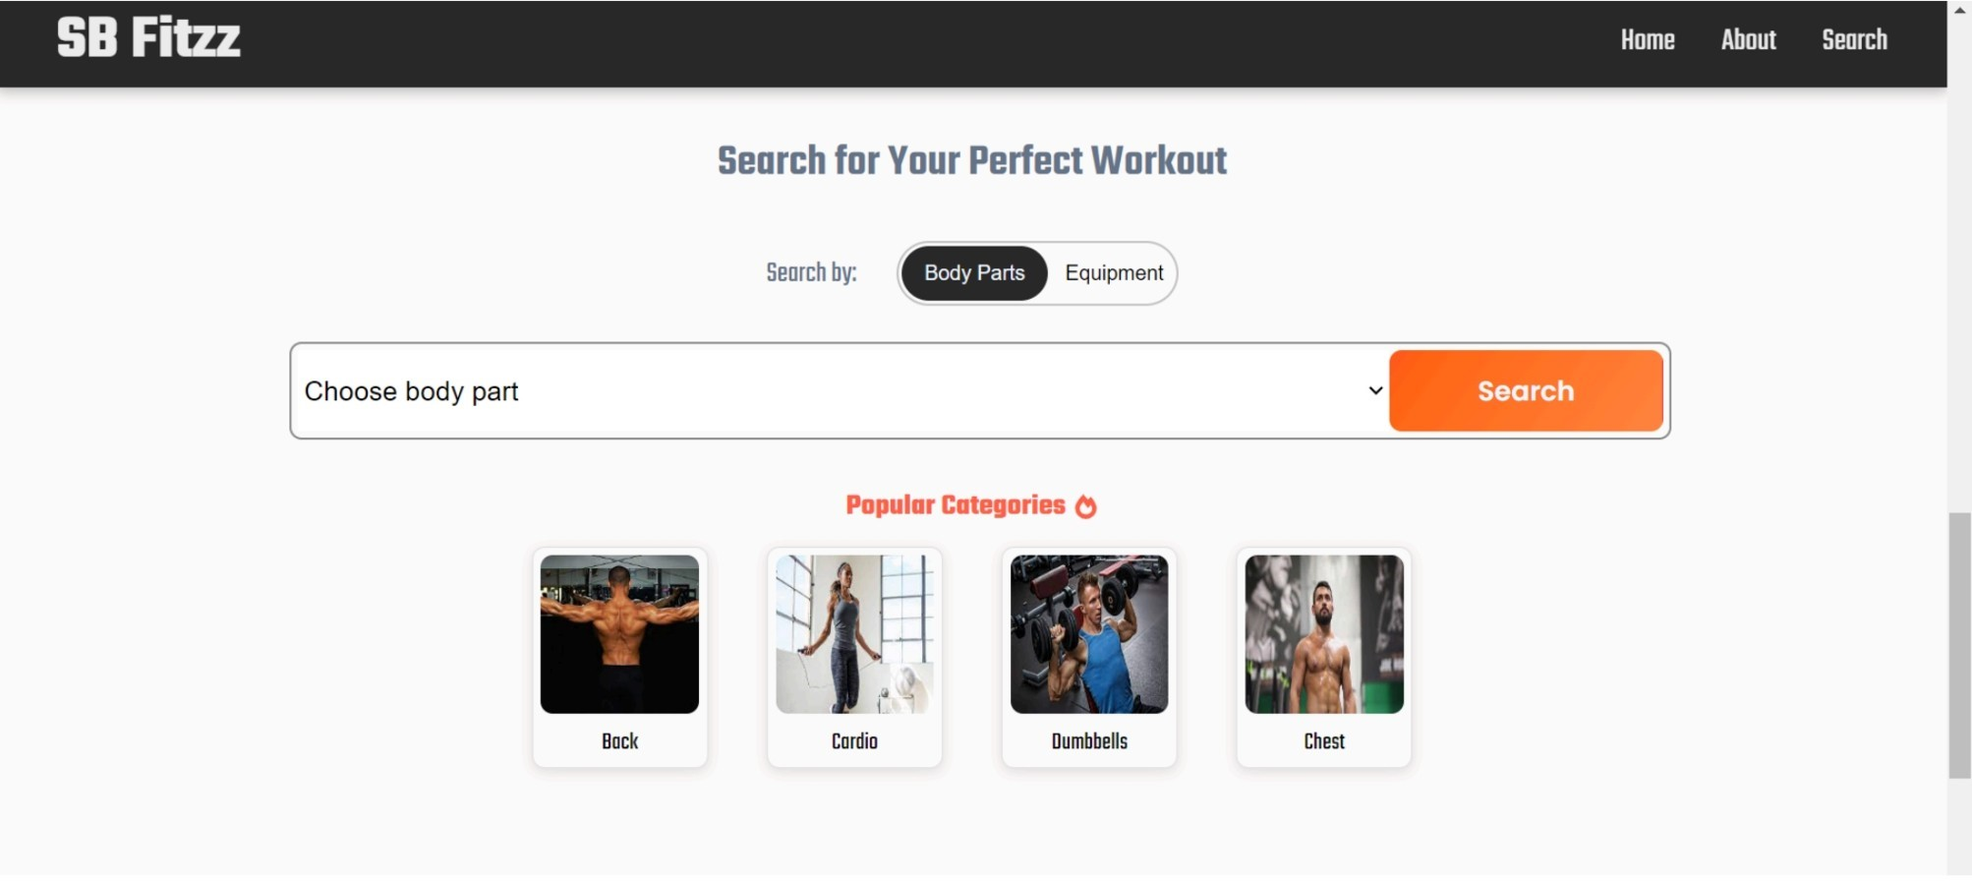

*Fig 9.3:Screenshot 3*

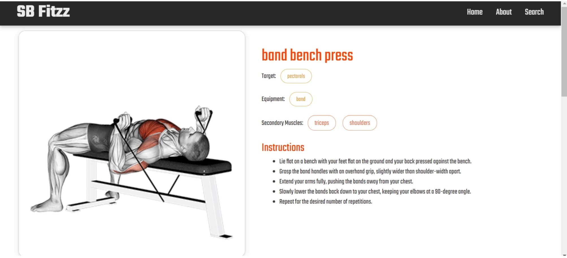

*Fig 9.4:Screenshot 4*

# 10.STYLING

**10.1 Css Framework/Libraries:**

The Fitness App implements a structured approach to styling, ensuring consistency, responsiveness, and an engaging user experience. The styling system focuses on modularity, reusability, and optimization to create a seamless interface.

1. **Styling Approaches:**

The app employs different styling methods depending on the component and use case:

**Global Styles –** Used for universal styles like fonts, colors, and default spacing.

**Component-Level Styles –** Managed with CSS Modules or Styled Components to avoid conflicts.

**Framework-Based Styling –** Uses Material-UI, Tailwind CSS, or Bootstrap for prebuilt UI components.

**Dynamic Styling –** Uses CSS-in-JS for theme switching and conditional styling**.**

1. **Responsive Design and Layouts:**

The Fitness App is designed using a mobile-first approach, ensuring proper layout adjustments across different devices.

**Flexbox & CSS Grid –** Used for structuring layouts dynamically.

**Media Queries –** Define custom breakpoints to optimize the UI for different screen sizes.

**Container Queries –** Allow components to adjust their styles based on available space.

**Example:** Responsive Grid Layout

.grid-container { display: grid; grid-template-columns: repeat(auto-fit, minmax(250px, 1fr)); gap: 20px;

}

@media (max-width: 768px) {

.grid-container { grid-template-columns: 1fr;

}

}

**3. Theming and Customization:**

The app supports light and dark mode using CSS variables and Material-UI's theme provider.

**CSS Variables –** Used for defining color palettes and font sizes.

**Theme Provider (Material-UI) –** Manages global styles dynamically**.**

**Custom Fonts and Icons** – Ensures branding consistency**.**

**Example:** Theme Toggle Using CSS Variables

**:**root {

--background-color: #ffffff;

--text-color: #333;

}

.dark-mode {

--background-color: #1e1e1e;

--text-color: #fff;

}\ const toggleTheme = () => { document.body.classList.toggle("dark-mode"); };

**4. Interactive UI and Animations:**

To improve engagement, smooth animations and transitions are implemented.

**Hover Effects –** Enhance UI interactions with smooth state changes.

**CSS Transitions –** Provide subtle effects for UI elements like buttons.

**Framer Motion –** Adds advanced animations and page transitions.

**Example:** Animated Button with CSS

# 11.TESTING

**11.1 Testing Strategy:**

Testing in the Fitness App

The Fitness App uses a structured testing approach to ensure functionality, performance, and reliability. Various testing techniques are implemented, including unit testing, integration testing, end-to-end (E2E) testing, and performance testing.

**1. Types of Testing Used:**

1. **Unit Testing:**

Focuses on testing individual components and functions.

Ensures that each component behaves as expected. Uses Jest and React Testing Library for React components.

1. **Integration Testing:**

Tests how different components work together.

Verifies interactions between UI components and API calls.

1. **End-to-End (E2E) Testing:**

Tests the entire app workflow from user input to output. Simulates real user interactions using Cypress or Playwright.

1. **Performance Testing:**

Measures load time and responsiveness.

Uses Lighthouse and WebPageTest to analyze speed.

1. **Accessibility Testing:**

Ensures compliance with WCAG (Web Content Accessibility Guidelines).

Uses axe-core and Lighthouse for accessibility checks.

1. **Tools and Libraries Used:**

Jest – JavaScript testing framework for unit and integration tests.

React Testing Library – Tests React components without relying on implementation details.

Cypress – Automates E2E testing in a browser environment.

Playwright – Alternative for E2E testing with multiple browser support.

Lighthouse – Measures performance, accessibility, and SEO. axe-core – Checks accessibility issues in UI components.

1. **Example Test Implementations:**

**a) Unit Testing a Component with Jest & React Testing Library:** Example: Testing a button component import { render, screen, fireEvent } from "@testing-library/react"; import Button from "../components/Button"; test("renders button with correct text", () => { render(<Button text="Click Me" />); const buttonElement = screen.getByText(/click me/i); expect(buttonElement).toBeInTheDocument();

}); test("triggers click event", () => { const handleClick = jest.fn(); render(<Button text="Click Me" onClick={handleClick} />); fireEvent.click(screen.getByText(/click me/i)); expect(handleClick).toHaveBeenCalledTimes(1);

});

# 12.SCREENSHOTS OR DEMO



*Fig 12.1:Screenshot 1*



*Fig 12.2:Screenshot 2*



*Fig 12.3:Screenshot 3*



*Fig 12.4:Screenshot 4*

# 13.KNOWN ISSUES

1. **Slow Initial Load Time:**

The app's initial loading time can be slow, especially on low-end devices or slow networks.

This is mainly due to large JavaScript bundles and multiple API calls on startup.

Possible improvements include code splitting, lazy loading, and optimizing assets.

1. **Inconsistent API Response Handling:**

Some API responses may take longer than expected, causing delayed UI updates.

In rare cases, network failures may result in stale or missing data.

Implementing better caching and error handling can improve the user experience**.**

1. **Mobile Responsiveness Issues:**

Certain UI components may not render correctly on smaller screen sizes.

Buttons and text fields may overlap on devices with different aspect ratios.

Additional CSS adjustments and media queries can enhance responsiveness**.**

1. **Login Authentication Delay:**

Some users may experience a delay when logging in, especially when authentication servers take longer to respond.This could be due to session handling issues or slow third-party authentication APIs.Implementing better loading indicators and optimizing API calls can mitigate this issue.

1. **Workout Tracking Sync Issues:**

Some users report that their workout progress is not syncing correctly between devices.

This may be due to local storage conflicts or server-side delays in updating user data.

Adding manual refresh options and improving real-time sync mechanisms can help resolve this.

# 14.FUTURE ENHANCEMENTS

To improve user experience and functionality, several enhancements are planned for future updates of the Fitness App. These improvements focus on performance optimization, new features, better personalization, and enhanced security**.**

1. **Offline Mode Support:**

**Enable users to track workouts and access saved data without an internet connection.**

**Implement local storage and caching for a seamless offline experience.**

1. **AI-Powered Workout Recommendations:**

Use machine learning to suggest personalized workout plans based on user activity, fitness goals, and progress.Improve workout difficulty adjustments based on real-time performance data**.**

1. **Enhanced Progress Tracking and Analytics:**

Introduce detailed workout analytics, including calorie burn estimation and heart rate tracking.Display weekly and monthly performance trends to help users stay motivated.

1. **Social & Community Features:**

Add a leaderboard system where users can challenge friends and earn rewards.

Enable users to share progress, achievements, and workout routines on social media.

Introduce community challenges for added motivation.

1. **Voice & Gesture Controls:**

Implement voice commands to start/stop workouts or switch exercises hands-free.

Introduce gesture-based navigation for a more interactive experience.